Uniform Circular Motion Review WS + Artificial Gravity
- (Hori) A race car going 32 m/s rounds a curve 56 m in radius. Calculate the car’s centripetal acceleration.

- (Hori) A runner of mass 67 kg moving at a speed of 8.8 m/s rounds a bend with radius of 25 m. Calculate the centripetal force acting on the runners.

- (Hori) An athlete whirls a 7.00 kg hammer tied to the end of a 1.3 m chain in a horizontal circle. The hammer makes one revolution in 1.0 second
  - What is the centripetal acceleration of the hammer?
  - What is the tension in the chain?

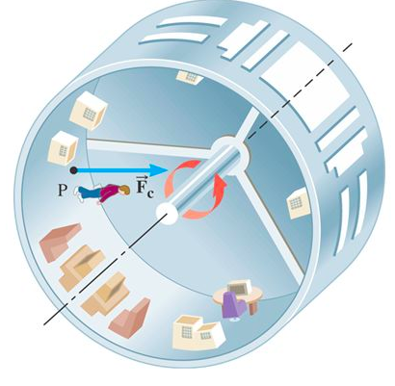
- (Space: Artificial G) One of the problems astronauts who live on the international space station experience after long period of time is muscle atrophy because of living in a content state of free fall and apparent (not actual) weightlessness. One potential solution in the future would be to spin modules of a space station to induce artificial gravity through centripetal acceleration. Because of rotational motion, any person or object inside would feel a force directed towards the center. At what speed must the surface of a cylinder-shaped space station with a radius of 1700 m have to move so that an astronaut experiences a force equal to his weight on earth?

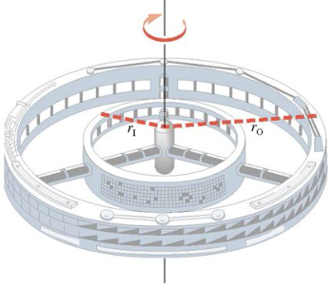
- (Space: Artificial G) A space laboratory is rotating to create artificial gravity. Its period is chosen so that the outer ring ($r=2150 m)$ simulates the acceleration due to gravity on Earth. What should the radius of the inner ring be so that it simulates the acceleration due to gravity on the surface of Mars ($3.72 m/s^{2}$)

- (Space: Artificial G) Early sceptics of the idea of a rotating Earth said that the fast spin of the Earth would throw people at the equator into space.
  - Calculate the speed of a 97 kg person standing on the equator.
  - Calculate the force needed to accelerate this person in the circle
  - Calculate the force of gravity acting on the person
  - What is the person’s apparent weight?
  - If the rotation of the Earth was increased so that the centripetal acceleration was equal to the acceleration due to gravity, how fast would the person be moving?
  - How man minutes long would one day be in this case?

- (Vert) A popular daredevil trick is to complete a vertical loop on a motorcycle. This trick is dangerous, however, because if the motorcycle does not travel with enough speed, the rider falls off the track before reaching the top of the loop. What is the minimum speed (at the bottom) necessary for a rider to successfully go around a vertical loop of radius 10.0 m?

- (Vert) A 0.25 kg mass attached to a string of length 1 m is spun in a horizontal circle. At what speed must it travel so that the angle the sting makes with horizontal is 30 degree? (hint: start by drawing a free body diagram)

1) $18 m/s^{2}$ | 2) 210 N | 3) $51 m/s^{2}$; 360 N | 4) 130 m/s
5) 816 m | 6) 470 m/s; 3.3 N; 950 N; 947 N; 7900 m/s; 85 mins | 7) 9.9 m/s | 8) 3.83 m/s
More Gravitation and Circular Motion Review:
- (Space: Kepler)
(a) Uranus has an orbital period of 84 years. What is its average distance from the sun?

(b) Neptune’s orbit is 50% bigger than the orbit of Uranus. What is the orbital period for Neptune?

- (Space) A 5800 kg object is lifted from the Earth’s surface to a radius of 2.3 x 10⁷ m. What is the gravitational field strength of the Earth at this location?

- (Space: Kepler) A 1500 kg satellite orbits the earth at a radius of 8.2 x 10⁶ m. What is the period (time to complete one orbit) for the space shuttle?

- (Space) A 6800 kg space probe is in a circular orbit of radius 8.0 x 10⁹ m about our Sun.
  - What is the orbital speed of this space probe?

  - Suppose the Sun was to suddenly collapse to 1/10 of its present radius without any change in mass. The space probe’s orbital speed about the Sun will:

____ Increase ____ Decrease ____ Stay the same

  - Using principles of physics explain your answer.

_________________________________________________________________________________________

_________________________________________________________________________________________

_________________________________________________________________________________________

- (Space) A 2500 kg rocket is lifted from the surface of the earth to a vertical height of 18000 m above the earth’s surface.
- What is the potential energy of the rocket while it is sitting on the Earth’s surface?

- What is the potential energy of the rocket when it is at 18000 m above the Earth’s surface?

- What work did the rockets on the rocket do in lifting this rocket from the Earth’s surface to a height of 18000 m?

- (Space) A 6500 kg satellite is in geostationary orbit around the Earth at a radius of 4.2 x 10⁷ m/s.
- What does Geostationary mean? (1 mark)

- What is the total energy of this satellite at this distance from the earth? (3 marks)

