Physics 12 Circular Motion Assignment Name:________________________
Mark:_____________/

A small plane makes a complete circle with a radius of 3500 m in 2.0 min. What is the centripetal acceleration of the plane?

Ans:___________________

(Vertical) A 3.5 kg object is whirled in a vertical circle whose radius is 1.0 m.
a) What is the minimum speed at the top to maintain circular motion?
b) If the string can only support 1000 N of tension force before breaking, what is maximum speed at the bottom?

a:___________________

b:___________________

(Banked/unbanked Car)A 1000 kg car is traveling at 20 m/s around an unbanked turn with a radius of 90.0 m.
- What is the minimum coefficient of friction required so that the car doesn’t skid?
- the same car above is now driving on the highway under very icy (no friction) condition. What is the maximum speed of the car if it traveling around a 20.0º banked corner with a radius of 90 m?
- What is the maximum speed of the car if it traveling around a 20.0º banked corner with a radius of 90 m and μ =0.45

a:_____________________
b:_____________________
c:_____________________
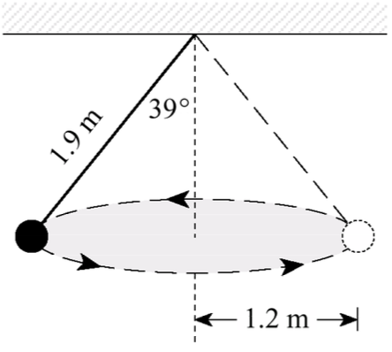
The diagram show an object of mass 3.0 kg travelling in a circular path or radius 1.2m while suspended by a piece of string of length 1.9 m. What is the centripetal force on the mass?

Ans:___________________

4. | (Gravitation)A 25000 kg rock is located at a distance of 7.6 x 10⁸ m away from a small planet of mass 7.8 x 10²³ kg. What is the mutual force of attraction between these two objects?  Ans:_____________________
5. | (Gravitation)A 5800 kg object is lifted from the Earth’s surface to a radius of 2.3 x 10⁷ m.  - What is the gravitational field strength of the Earth at this location?  - What is the orbital period (time to complete one orbit) of the object?  a:___________________  b:___________________
6. | What is the escape velocity of a rocket trying to escape from the surface of the Moon?  Ans:___________________
7. | A 6500 kg satellite is in geostationary orbit around Mars ($m=6.39×{10}^{23}kg, rotation period=88643 s)$  - What does Geostationary mean?  - Calculate the orbital radius  - What is the total energy of this satellite at this distance from Mars?  b)___________________  c)___________________
8. | A 2500 kg rocket is lifted from the surface of the earth to a vertical height of 18000 m above the earth’s surface.  - What is the potential energy of the rocket while it is sitting on the Earth’s surface?  - What is the potential energy of the rocket when it is at 18000 m above the Earth’s surface?  - What is the impact speed when the rocket falls back to the surface  a)___________________  b)___________________  c)___________________

